Ethan Allen Corwait Black Sofa

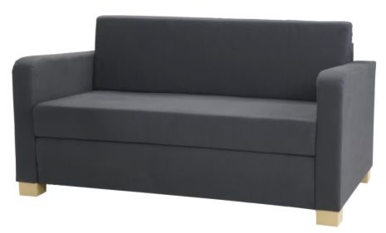

|  |
| --- |
| **DESCRIPTION** |
| The Corwait Sofa produced by Ethan Allen Co, presents a sleek, low profile design that is both functional and comfortable. The extra-wide and deep relaxed form on top and cleaning long legs with wooden steel endorse bottom provides stability for the sofa. The company has progressed to revolutionize the world with the help of their interior designing through the good. |

|  |  |  |
| --- | --- | --- |
| **Price** | **1275$** | |
| **Dimensions** | **H** x **W** x **L** | **28in x 32in x 66in** |
| **Features** | **Comfortable for two but 4 people can also sit at once with air tight pressure and shock absorbers enable it to have long healthy life.** | |
| **Finished** | **Black Netted Form** | |
| **Available in** | **Black and Dark Gray** | |